附件1 / Appendix 1
国际学生住宿登记表
REGISTRATION FORM OF RESIDENCE FOR INTERNATIONAL STUDENT
中文姓名  Chinese Name |  | 英文姓名  English Name
宿舍地址  Dormitory Address |  | 联系电话  Contact Tel No.
性别  Gender |  | 出生日期  Date of Birth
证件名称  Type of ID |  | 证件号码  ID No.
国籍或地区  Nationality |  | 国（境)外住址  Overseas Address
入住日期  Date of Arrival |  | 离开日期  Date of Departure
- 本人同意支付在此宿舍入住期间所产生的费用，若不能遵守宿舍管理规定或严重违纪行为，我院随时收回住房，学生住宿问题由自己解决，费用自理。
I agree to pay for all the expenses that will be incurred as I live in the dormitory as well as any other expenses. If I break the rules and regulations of the dormitory or have any serious actions against the relevant discipline, the Institute has the right to take the accommodation back, and the international student shall solve the accommodation problem and cover the relevant expenses by himself/herself.
- 本人承诺严格遵守学校各项规章制度以及留学生宿舍管理规定，爱护公物，如人为损坏家具或电器设备，要照价赔偿。
I agree to comply with all the rules and regulations of IWHR and regulations for international student apartment. I agree to take good care of the public property and pay for any intended damage to the electric appliances or furniture at its original price.
备注：
Notes：
学生签名：  Student’s Signature： |  | 单位签章：  Seal of IWHR Graduate School：

附件2 / Appendix 2

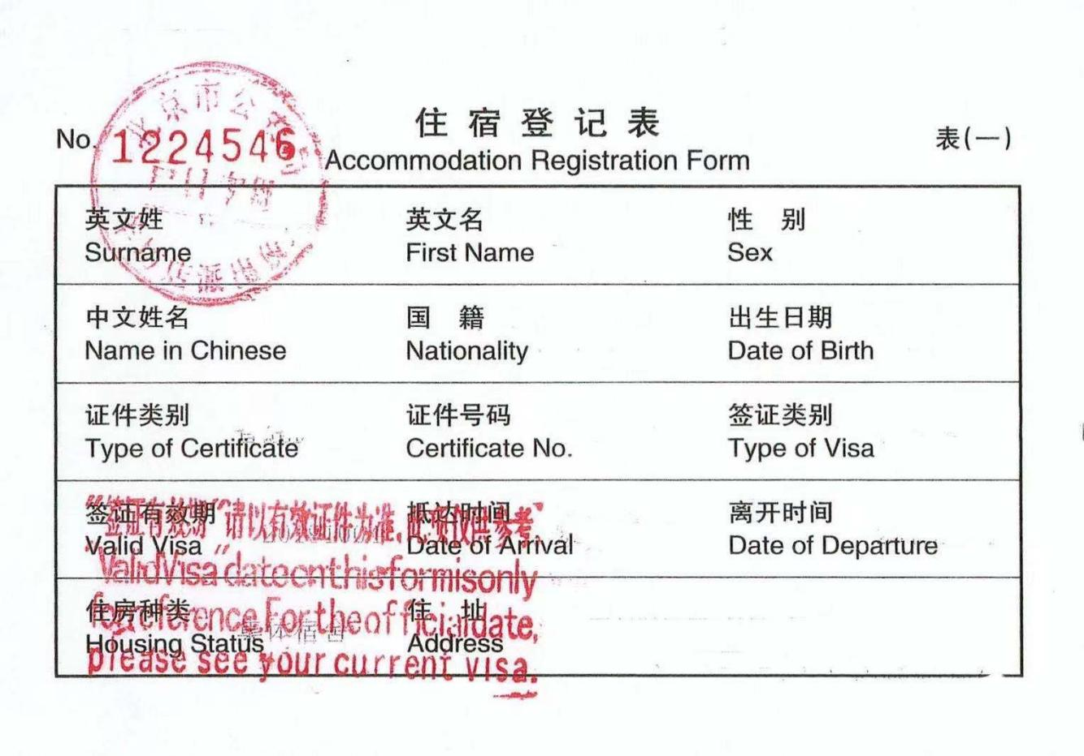

附件3 / Appendix 3
中国水利水电科学研究院
China Institute of Water Resources and Hydropower RESEARCH

请假单
Leave Application Form
姓名  Name |  | 学号  Student ID |  | 专业  Program
请假时间
Leave Duration
请假原因
Leave Reasons
导师意见  Supervisor’s Comments |  |  | 研究生院签章  Seal of IWHR Graduate School

附件4 / Appendix 4
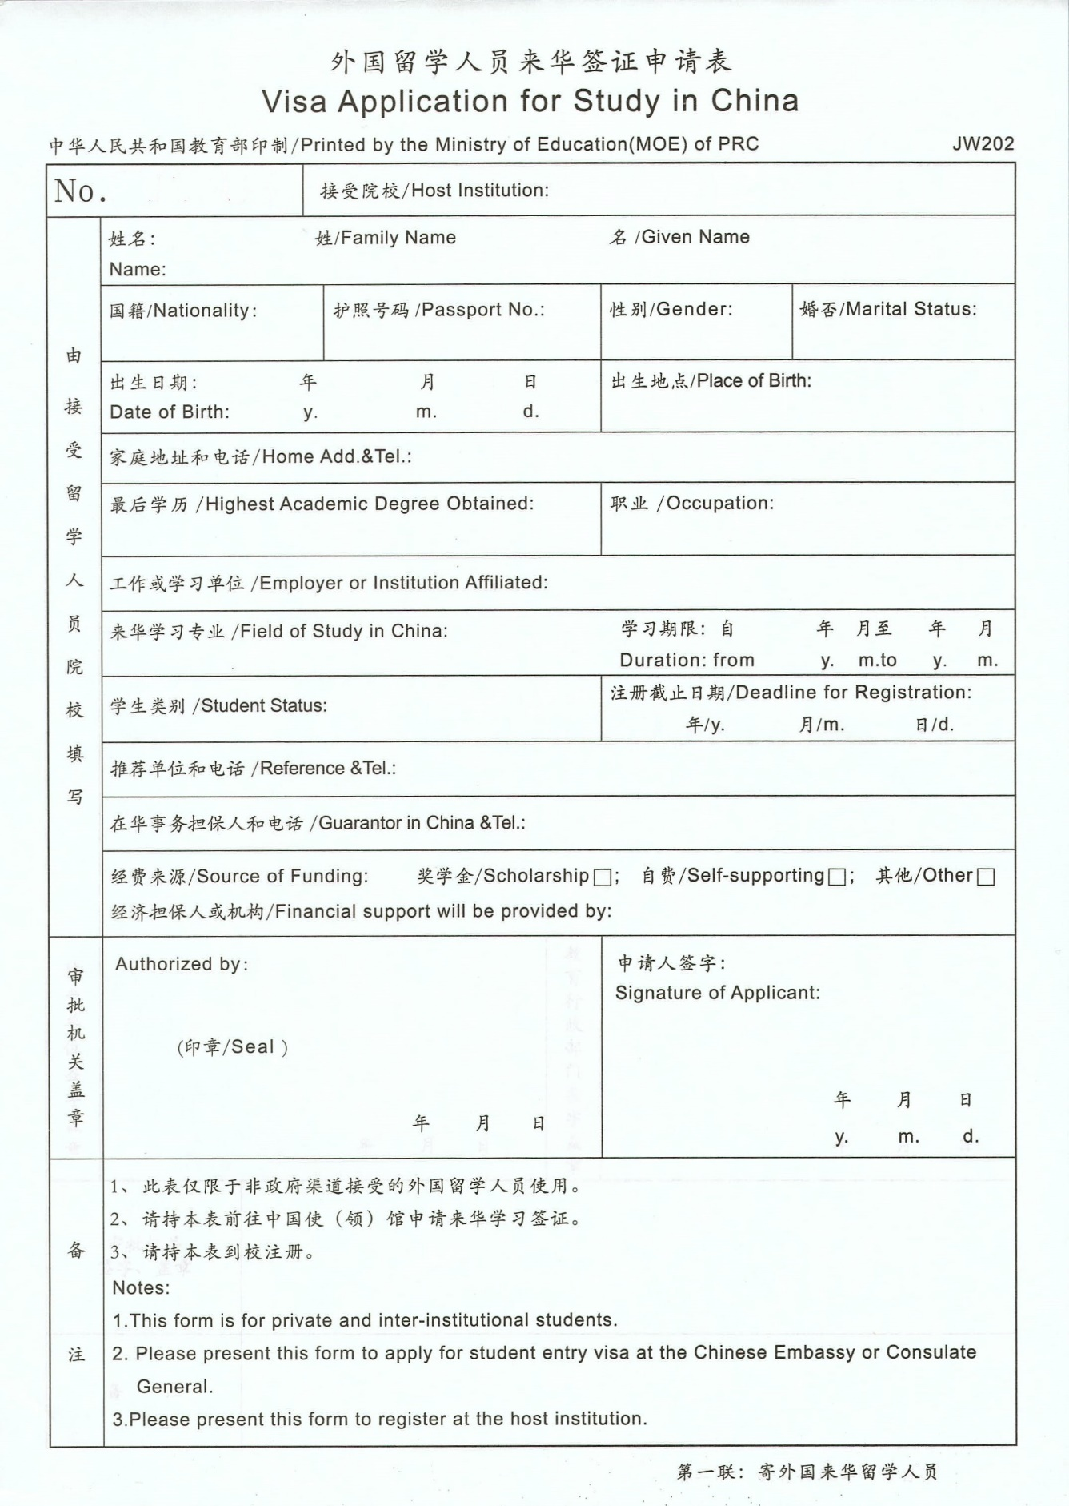

附件5 / Appendix 5
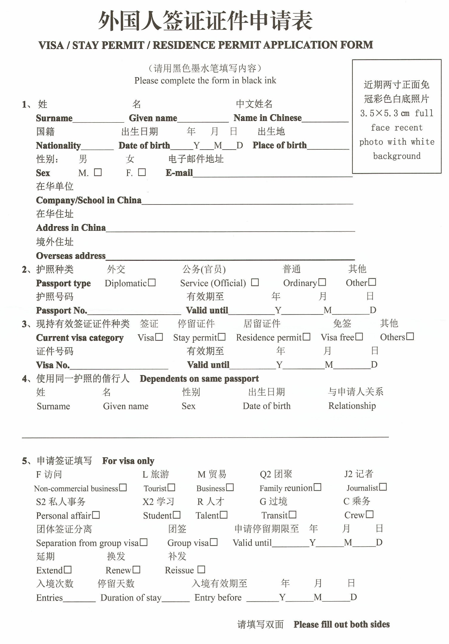

附件6 / Appendix 6
中国水利水电科学研究院
China Institute of Water Resources and Hydropower RESEARCH

居留许可延期申请函
Application for Residence Permit Extension
北京市公安局出入境管理局：
The Exit and Entry Administration of Beijing Municipal Public Security Bureau:

我院×××专业国际学生×××，×××籍，护照号×××,出生于××××年××月××日，在我院学习时间为××××年××月至××××年××月。
(Name), nationality of ×××, passport No. ×××, born on ××××/××/××, is a full-time registered student at IWHR studying on ×××. This student started the course in ××/××××, and the expected date of graduation is in ××/××××.
现因××××为其申请居留许可延期至××××年××月××日。望予以批准。
Due to xxx, we hereby apply for an extension of his/ her residence permit until ××/××××. Looking forward to your approval!

中国水利水电科学研究院研究生院
IWHR Graduate School

年/Y 月/M 日/D

附件7 / Appendix 7
中国水利水电科学研究院
China Institute of Water Resources and Hydropower RESEARCH

同意国际学生转学函
Letter of Approval for International Student’s Transfer

兹有我院××××籍国际学生××××，护照号××××,于××××年××月至今为我院在读博士/硕士研究生，现要求转学。经研究，决定同意其转校。
This is to certificate that (name), nationality of ×××, passport No. ×××, is a full-time registered doctoral/ master’s student at IWHR from ××/×××× until now. He/she now would like to request for a transfer to another university/college. With this letter, we hereby confirm that his/ her transfer request has been approved by IWHR.

中国水利水电科学研究院研究生院
IWHR Graduate School

年/Y 月/M 日/D

